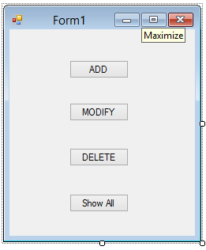

Public Class Form1

Private Sub Button1_Click(ByVal sender As System.Object, ByVal e As System.EventArgs) Handles AddButton.Click

Dim frm = New NameForm()

frm.ShowDialog()

End Sub

Private Sub Form1_Load(ByVal sender As System.Object, ByVal e As System.EventArgs) Handles MyBase.Load

End Sub

Private Sub ModifyButton_Click(ByVal sender As System.Object, ByVal e As System.EventArgs) Handles ModifyButton.Click

Dim frm = New ModifyForm()

frm.ShowDialog()

End Sub

Private Sub DeleteButton_Click(ByVal sender As System.Object, ByVal e As System.EventArgs) Handles DeleteButton.Click

Dim frm = New DeleteForm()

frm.ShowDialog()

End Sub

Private Sub Button4_Click(ByVal sender As System.Object, ByVal e As System.EventArgs) Handles Button4.Click

Dim frm = New ShowAllForm()

frm.Show()

End Sub

End Class

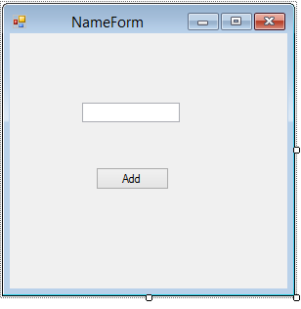

Imports System.Data.SqlClient

Public Class NameForm

Private Sub AddButton_Click(ByVal sender As System.Object, ByVal e As System.EventArgs) Handles AddButton.Click

Dim conn As SqlConnection = New SqlConnection("Data Source=SAKSHI\MSSQLEXPRESS12;Initial Catalog=somedb;Integrated Security=True")

Dim cmd = New SqlCommand("INSERT INTO student(name) VALUES('" & NameTextBox.Text & "')", conn)

conn.Open()

cmd.ExecuteNonQuery()

conn.Close()

MsgBox("Row Added")

Me.Close()

End SubEnd Class

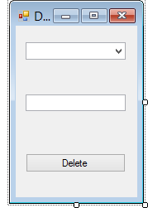

Imports System.Data.SqlClient

Public Class DeleteForm

Dim conn

Dim cmd

Private Sub IdComboBox_SelectedIndexChanged(ByVal sender As System.Object, ByVal e As System.EventArgs) Handles IdComboBox.SelectedIndexChanged

conn = New SqlConnection("Data Source=SAKSHI\MSSQLEXPRESS12;Initial Catalog=somedb;Integrated Security=True")

cmd = New SqlCommand("SELECT name FROM student WHERE id = " & IdComboBox.SelectedItem, conn)

conn.Open()

Dim reader = cmd.ExecuteReader()

While reader.Read()

NameTextBox.Text = reader("name")

End While

conn.Close()

End Sub

Private Sub DeleteForm_Load(ByVal sender As System.Object, ByVal e As System.EventArgs) Handles MyBase.Load

conn = New SqlConnection("Data Source=SAKSHI\MSSQLEXPRESS12;Initial Catalog=somedb;Integrated Security=True")

cmd = New SqlCommand("SELECT * FROM student", conn)

conn.Open()

Dim reader = cmd.ExecuteReader()

While reader.Read()

IdComboBox.Items.Add(reader("id"))

End While

conn.Close()

End Sub

Private Sub UpdateButton_Click(ByVal sender As System.Object, ByVal e As System.EventArgs) Handles UpdateButton.Click

conn = New SqlConnection("Data Source=SAKSHI\MSSQLEXPRESS12;Initial Catalog=somedb;Integrated Security=True")

Dim id = IdComboBox.SelectedItem

cmd = New SqlCommand("DELETE FROM student WHERE name = '" & NameTextBox.Text & "'", conn)

conn.Open()

Dim reader = cmd.ExecuteNonQuery()

MsgBox("Row deleted")

Me.Close()

conn.Close()

End Sub

End Class

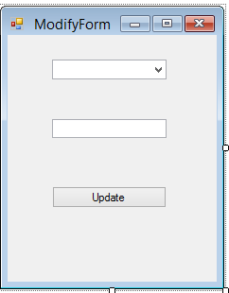

Imports System.Data.SqlClient

Public Class ModifyForm

Dim conn As SqlConnection

Dim cmd As SqlCommand

Private Sub ComboBox1_SelectedIndexChanged(ByVal sender As System.Object, ByVal e As System.EventArgs) Handles IdComboBox.SelectedIndexChanged

conn = New SqlConnection("Data Source=SAKSHI\MSSQLEXPRESS12;Initial Catalog=somedb;Integrated Security=True")

cmd = New SqlCommand("SELECT name FROM student WHERE id = " & IdComboBox.SelectedItem, conn)

conn.Open()

Dim reader = cmd.ExecuteReader()

While reader.Read()

NameTextBox.Text = reader("name")

End While

conn.Close()

End Sub

Private Sub UpdateButton_Click(ByVal sender As System.Object, ByVal e As System.EventArgs) Handles UpdateButton.Click

conn = New SqlConnection("Data Source=SAKSHI\MSSQLEXPRESS12;Initial Catalog=somedb;Integrated Security=True")

Dim id = IdComboBox.SelectedItem

cmd = New SqlCommand("UPDATE student SET name = '" & NameTextBox.Text & "'", conn)

conn.Open()

Dim reader = cmd.ExecuteNonQuery()

MsgBox("Row Updated")

Me.Close()

conn.Close()

End Sub

Private Sub ModifyForm_Load(ByVal sender As System.Object, ByVal e As System.EventArgs) Handles MyBase.Load

conn = New SqlConnection("Data Source=SAKSHI\MSSQLEXPRESS12;Initial Catalog=somedb;Integrated Security=True")

cmd = New SqlCommand("SELECT * FROM student", conn)

conn.Open()

Dim reader = cmd.ExecuteReader()

While reader.Read()

IdComboBox.Items.Add(reader("id"))

End While

conn.Close()

End Sub

End Class

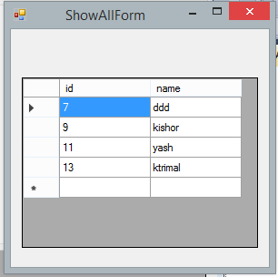

Imports System.Data.SqlClient

Public Class ShowAllForm

Dim conn

Dim cmd

Private Sub ShowAllForm_Load(ByVal sender As System.Object, ByVal e As System.EventArgs) Handles MyBase.Load

conn = New SqlConnection("Data Source=SAKSHI\MSSQLEXPRESS12;Initial Catalog=somedb;Integrated Security=True")

cmd = New SqlCommand("SELECT * FROM student", conn)

conn.Open()

Dim reader = cmd.ExecuteReader()

DataGridView1.Columns.Add("id", "id")

DataGridView1.Columns.Add("name", "name")

While reader.Read()

DataGridView1.Rows.Add(reader("id"), reader("name"))

End While

conn.Close()

End Sub

End Class